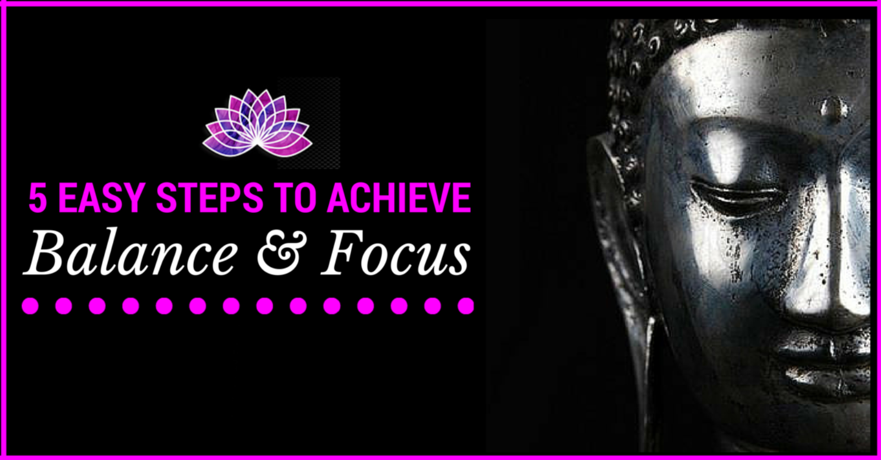

- STOP…
This first step seems the easiest to apply, can also be the one that can have its challenges when you are used to being the mouse on the wheel of go, go go!!! To stop ones racing thought is to recognize that your life is not in sequence with the flow. Flow of life, energy and connection to self. Some symptoms that may occur on a physical level is racing thoughts, increased breathe, running around with your head chopped off, a must do attitude that everything must be done now. All these symptoms decreases the ability to focus on any one task effectively because you are always looking at the list that is a mile long with must do’s on it and just trying to get through each one as fast as possible. Your natural state of balance is out the window, almost as if your life is on fast-forward.

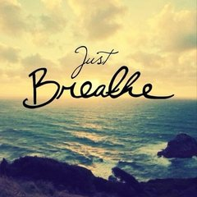
- BREATHE…
Close your eyes as this draw all your attention and focus to only the breath. When the eyes are closed it engages the brain to start to become quieter. Visualize oxygen entering into your chest filling up your whole chest area as it rises with the breath. Feel oxygen flowing down to your lungs and filtering that oxygen throughout your entire body until it reaches every cell. Upon exhalation, let go of all your demands you feel is present which is causing overwhelm and increasing a negative state from the within. Give yourself permission discharge stress from each cell and filter it back up through your lungs and exit out via your mouth. Continue this step until your only focus is on your breath.
Your body will start to relax, your focus will increase, you’re breath will become calm and steady. As your breathing slows to a steady pace, the physical body will respond to this new state of wellbeing and induce relaxation.

- ELEVATOR THOUGHTS…
Collect all your thoughts from your mind and visualize an elevator at the center of your mind. The doors are open to place every thought, feeling, emotion you are experiencing right now into the elevator and close the door.

- HEARTSPACE BREATHING…
Now the elevator with all your thoughts, feelings and emotions will start the journey down from your mind until it reaches your heart area. At the same time your breath enters in from your nose, traveling down your chest and exits via your heart.
The door opens of the elevator and your collective thoughts stream out through your heart with your breath.
This time the breath is focused to enter in and out from your heart area. This is known as heart space breathing. With each heartspace breath, your elevator of thoughts dissipates until nothing exists.
Your thoughts are now free from constraints, stress and pressure. The mind becomes still with clarity of thoughts and your body re establishes balance so that your mind body and spirit are harmoniously to work collective together to achieve a state of balance and focus.

- PRIORITIZE…
Now your daily to do list still requires attention, to complete all tasks. List your daily must do, just brain dump everything. Scale 1-10 based on order what is the most important that must get done. From the list, focus only on the first 3 tasks. With each of the 3 tasks write what is involved to complete the whole task. Some tasks may have 3,4 or 5 components before that 1 task is actually completed. This way you have a clear intention of what it will take step by step. Upon completion of each task either cross it out or tick it off. It is important that you visually see that you are accomplishing your tasks. To chunk into bite sizes your daily must do list enable you to work more proficiently. With a renewed state of mind, body and soul that is balanced and has the ability to effectively focus on your tasks more efficiently; this will create a state well-being.

