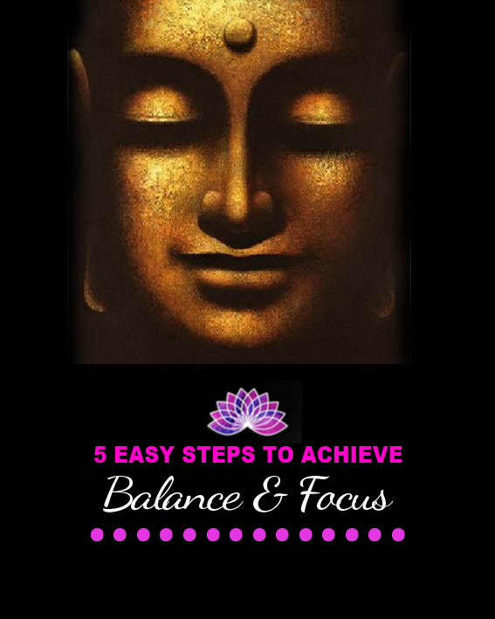

© Rachel Thompson Phillips

This first step may seem the easiest to apply but it can also be the one that offers the most challenges when you are used to being the mouse on the wheel of go, go go!!!

Stop your racing thoughts and you will recognize that you’re not in synch with the flow of life, energy and connection to self.

Some symptoms that you may be experiencing on a physical level may be; racing thoughts, increased breath, running around like a chook with it’s head chopped off, and a ‘must do’ attitude that everything must be done now.

All these symptoms decrease your ability to focus on any one task effectively, and because you are always looking at your ‘mile long’ list of must dos on and trying to get through each one as fast as possible you will find that your natural state of balance is out the window leaving you in a stressful state of perpetual fast-forward.

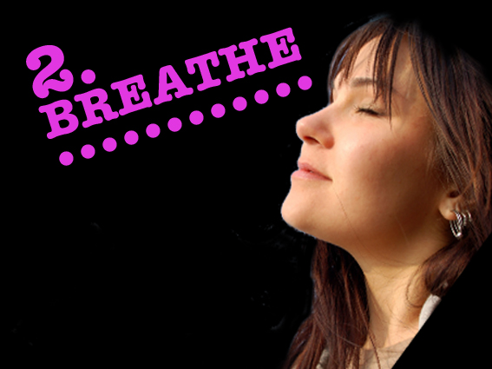

Close your eyes, as this draws all your attention and focus to only your breathing. When the eyes are closed it engages the brain to start to become quieter.

Visualize fresh, mountain air entering though your nose and feel your chest area filling up as it rises with your breath.

Feel it full your lungs as they deliver that oxygen throughout your entire body until it reaches every cell.

Breathe out and give yourself permission to discharge stress from each cell and filter it back up through your lungs and exit it out through your mouth.

Continue this step until your only focus is on your breath.

Feel your body start to relax, your focus increase and your breath will become calm and steady.

As your breathing slows to a steady pace, your body will respond to this new state of wellbeing and induce relaxation.
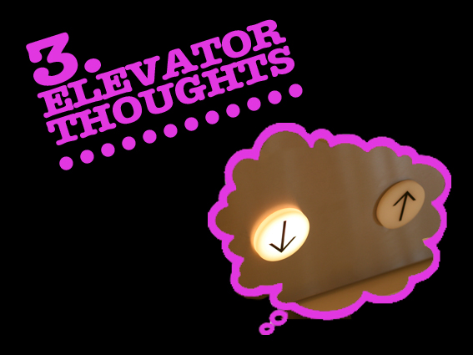

Visualize an elevator at the center of your mind. Collect all the thoughts in your mind and as the doors of the elevator open, place every thought, feeling, and emotion you are experiencing right now into the elevator and close the door.

Send the elevator with all your thoughts, feelings and emotions on it’s journey down until it reaches your heart area. At the same time feel your breath entering through your nose, and as the door of the elevator opens your collective thoughts stream out through your heart with your breath.

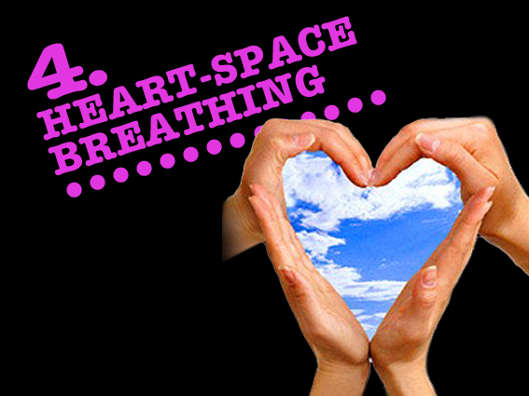

This time the breath is focused on entering in and exiting out from your heart area. This is known as heart-space breathing.

With each heart-space breath your elevator of thoughts, feelings and emotions empties until nothing exists.

Your thoughts are now free from constraints, stress and pressure. The mind becomes still with clarity of thoughts and your body re-establishes balance so that your mind, body and spirit are harmonised to work collectively to achieve a state of balance and focus.

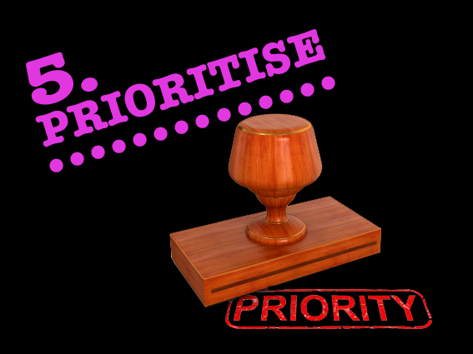

Your daily to do list still requires attention. List your daily must-dos, just brain-dump of everything that has to get attention. Scale the list 1-10 based on the order of what is the most important item that must get done.

From the list, focus only on the first 3 tasks. With each of the 3 tasks write what is involved to complete the whole task. Some tasks may have 3, 4 or 5 components before that 1 task is actually completed.

This way you’ll have a clear vision of what it will take step by step. Upon completion of each task either cross it out or tick it off.

It is important that you visually see that you are accomplishing your tasks.

Chunking your daily must-do list into bite sizes enable you to work more effectively with a renewed state of mind, body and soul that is balanced and has the ability to clearly focus on the tasks more efficiently;

These 5 tips will create a state well-being.

