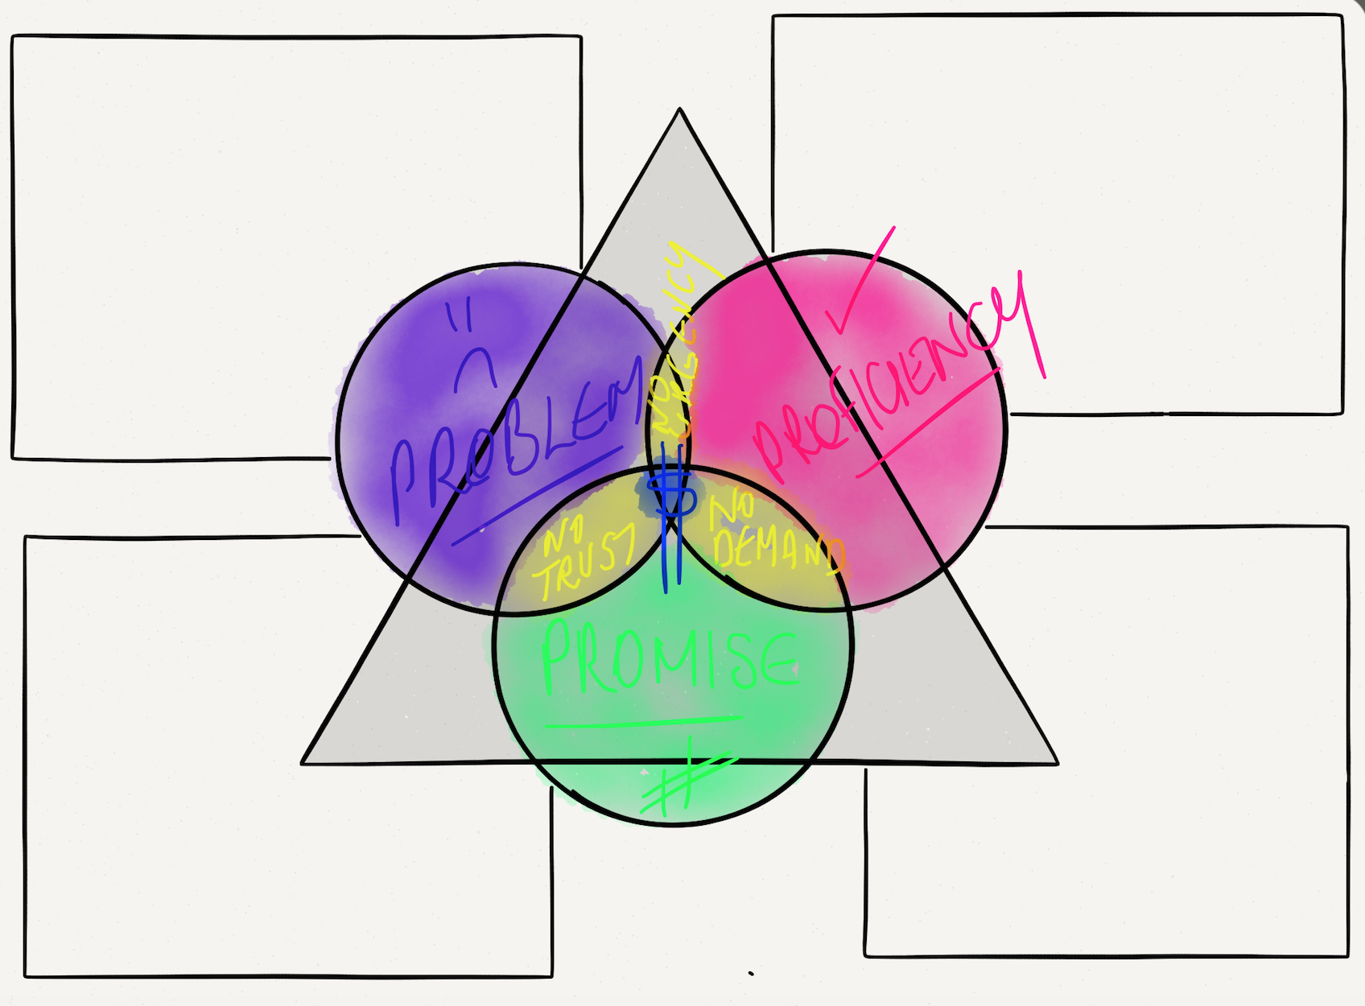
WWW.RACHAELTHOMPSONPHILLIPS.COM
PROFICIENCY
- Is your niche the people you love

- Are you seen as an expert in your industry
- Do you want to leave behind a legacy that will share your message for generations to come
PROMISE
- Are you change lives on a massive scale

- Are you living up to your true potential

- Are you living the life you deserve
PURPOSE
- Are you truly living your purpose

- Are you reaching the audience you desire

- Does your purpose, ignite your passion & light up your soul

PROBLEM
- Are you feeling frustrated with where you are now, want to reach a bigger audience

- Working such long hours doing one to one instead of one to many

- Limited by time and location

